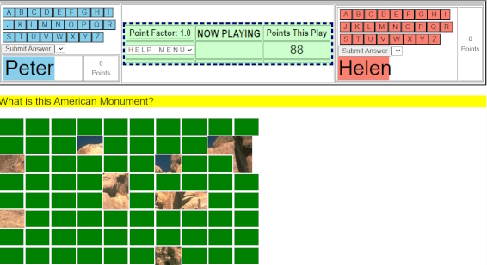
The above image shows Game type I after 12 seconds showing parts of an image that answers the question:
What is this American Monument?
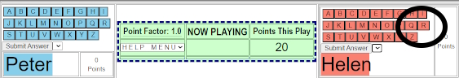
Th ethe above image, Helen thinks she knows the answer and is about to press the ”R” button.
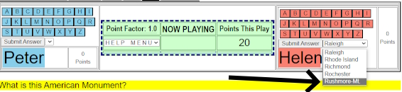
In the above image, Helen has pressed the “R” button and a drop-down menu with several possible names on it, including Rushmore-Mt, which she selects.
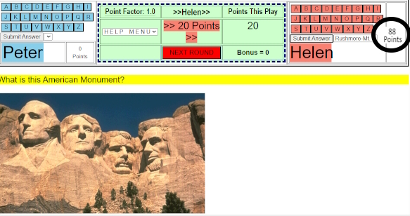
In the above image, Helen had correctly answered the question and received 88 points.

